Shanti Flaherty

**Pitch Document**

**Game Title:** Master of Havoc

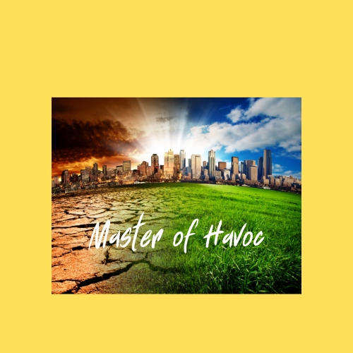

**Genre:** Simulation/Strategy

**Platform:** PowerPoint(computer/computer screen, mouse and/or touchscreen)

**Game Concept:** The player board would be a map of the world with icons placed in different countries/regions to represent either manmade or natural disasters. Players would click on then complete Disaster Challenges sequentially, 1-10, in order of complexity (e.g., thunderstorm & lightning, pandemic, tornado, etc.). After being introduced to the disaster scenario, players would click “I’m Ready!” and be taken to a screen with a timer – to represent the idea that there is limited time to make the right decisions to survive a disaster – then choose the correct Havoc Pack made up of tools & resources, actions, and skills/traits to survive the disaster. The goal would be to survive each of the ten disasters by picking the correct Havoc Pack (out of three options), to earn individual Disaster Badges that will eventually make up the complete Master of Havoc Badge.

**Target Audience:** Ages 12+

**Implementation Context:** Master of Havoc could be used as a tool to supplement/reinforce disaster and emergency preparedness curriculum that is already being implemented in schools across multiple cities and states (e.g., San Diego and Michigan). It could also be included as part of a larger classroom module on climate change and/or school safety/disaster preparedness, to help students and families better understand what they would need and what they would need to do to increase their chances of surviving a manmade or natural disaster. Additionally, it could be used to help teach “soft skills” such as critical thinking, problem-solving, and decision-making.

As a personal/self-education opportunity, the game could be made available on multiple, relevant national, state, and city government sites (e.g., HHS, Ready.gov, Denver.gov) to support citizens’ ability to prepare for and survive disaster situations that are common to their region (e.g., hurricanes, tornadoes, droughts) or the world at large (lightning & thunderstorms, pandemic).

It is worth noting that due to the requisite background knowledge and reading level to engage with the scenarios/content, this game would be most appropriate for those who are age 12 years and above.

**Learning Objectives:**

1. Given a limited amount of time, players should be able to identify the best tools & resources to use to survive a natural or manmade disaster.
2. Given a limited amount of time, players should be able to identify the best actions to take to survive a natural or manmade disaster.
3. Given a limited amount of time, players should be able to identify the best skills/traits to have to survive a natural or manmade disaster.

**Hook:** Many people have experienced, and/or have been directly impacted by, extreme weather events or other disasters, due to climate change and at times ignorance about how to best ensure their safety during a natural or manmade disaster. Additionally, according to David Ropeik (an expert in risk), people have a tendency to either act on instinct or fall prey to “The Perception Gap,” whereby they end up making choices that create greater risk (Ropeik, 2010). The goal of playing Master of Havoc would be to help people make better choices about how to keep themselves and others safe, when faced with a natural or manmade disaster and a limited amount of time to make the best decisions.

**Game mechanics:** After an introduction to the game, its purpose, and “How to Play,” players will start by clicking on the first Disaster Challenge icon on a world map. Once players enter the Disaster Challenge, a scenario will be presented in the form of a realistic situation, written bulletin, emergency warning, and/or news report. After reading or listening to the scenario, players will click “I’m Ready!” to be taken to a new screen that continues the scenario by starting a timer and giving players the option to choose one of three Disaster Packs to help them survive the disaster. If players fail to choose a pack in the amount of time they are given, they will be taken to a new screen that tells them they have run out of time and be prompted to return to the scenario, reread or re-listen to it, then try again. If players choose the correct Disaster Pack, they will be taken to a “Good!” screen and a brief explanation about why the pack they selected was the best choice to survive that particular disaster. Then, they will be awarded a Disaster Badge for the challenge. If players select incorrectly, they will be taken to an “Oh!” screen that explains why the pack was a bad choice/why tools & resources, actions, and/or skills listed in the pack would not be helpful for surviving that particular disaster and prompted to try again.

Play will continue with players returning to the world map screen and sequentially engaging in increasingly difficult Disaster Challenges, until they have earned all possible Disaster Badges. Once all badges have been earned, players will be awarded a complete Master of Havoc Badge.

**Special sauce:** While the game is designed to be played by a single person, it could be easily adapted to have multiple students/adults engage in play by having people work in groups to read and/or listen to each disaster scenario then discuss which Havoc Pack to choose and why. Through this kind of interaction, not only would critical-thinking, problem-solving, and decision-making be promoted, but also teamwork and idea/knowledge sharing. Ultimately, by playing the game, players can build knowledge and gain a sense of security/control if or when they find themselves in a real-life disaster situation.

**Environmental scan:** “Disaster Master” is an online game created by Ready.gov. that has some similarities to “Master of Havoc.” However, it seems more focused on preparedness than making decisions about how to survive a disaster in the heat of the moment. “Tidal Wave Ninja” is a game found on Kickstarter, but in contrast to the game I want to design it focuses on a single disaster – a tidal wave. “Disaster Defender” is another Kickstarter game that bears a resemblance to the game I want to create, but players are first responders rather than everyday people.

**Course feasibility:** I believe that I can create this game during this course, however time constraints may make it difficult to create all aspects I am considering (e.g., I may have to narrow the number of disasters or limit play to the U.S.).

**Design Document: Master of Havoc Game**

**Table of Contents**

1. Introduction/Overview
2. Target Audiences and Implementation Context
3. Learning Objectives
4. Hooks
5. Game Mechanics
6. Artificial Intelligence
7. Game Elements
8. Story Overview
9. Game Progression
10. User Interface
11. Implementation Artifacts and Guidelines
12. The Game Minute

**Introduction/Overview**

Welcome to Master of Havoc! In this game, players will learn about the best tools &

resources, actions, and skills to help them survive real-life natural and manmade disasters. As players progress through increasingly difficult Disaster Challenges, they will earn Disaster Badges for selecting the best Disaster Pack to survive each challenge. The goal is for players to learn what they will need and the appropriate actions to take if they ever find themselves in a disaster situation. Once players earn all the Disaster Badges, they will become Masters of Havoc.

**Target Audiences and Implementation Context**

Master of Havoc could be used as a tool to supplement/reinforce disaster and emergency preparedness curriculum that is already being implemented in schools across multiple cities and states. It could also be included as part of a larger classroom module on climate change and/or school safety/disaster preparedness, to help students and families better understand what they would need and what they would need to do to increase their chances of surviving a manmade or natural disaster, should they encounter one. Additionally, Master of Havoc could be used to help teach “soft skills” such as critical thinking, problem-solving, and decision-making. In an educational setting, players could complete at least three disaster challenges within a typical (45-50 minute) session/classroom period, across three to four sessions.

As a personal/self-education opportunity, the game could be made available on multiple, relevant national, state, and/or city government sites (e.g., HHS, Ready.gov, Denver.gov) to support citizens’ ability to prepare for and survive disaster situations that are common to their region (e.g., hurricanes, tornadoes, droughts) and/or the world at large (lightning & thunderstorms, pandemic).

It is worth noting that due to the requisite background knowledge and reading level to engage with the scenarios/content, this game would be most appropriate for those who are age 12 years and above.

**Learning Objectives**

1. Given a limited amount of time, players should be able to identify the best tools & resources to use to survive a natural or manmade disaster.
2. Given a limited amount of time, players should be able to identify the best actions to take to survive a natural or manmade disaster.
3. Given a limited amount of time, players should be able to identify the best skills/traits to have to survive a natural or manmade disaster.

Each Disaster Challenge will be presented as a scenario related to a specific natural or manmade disaster. A timer will be used for each challenge as a way to help players understand that during a disastrous event, there is often a limited amount of time to make the right decisions about the tools & resources, actions, and skills that will best help them survive the disaster. Players will need to use the time they are given to select the best Disaster Pack to survive. Players will be given three Disaster Packs to choose from (each pack will list a specific combination of tools & resources, actions, and skills). After selecting one of the three Disaster Packs, players will be taken to a new screen that either congratulates them for selecting the correct pack then awards them a Disaster Badge, or a screen that tells them they selected incorrectly. The congratulatory screen will explain why the pack was the best choice and provide additional relevant information, as needed. The incorrect response screens will explain why elements of the pack they selected would not help them survive the disaster scenario/would be bad choices and given the opportunity to try again.

**Hooks**

Many people have experienced, and/or have been directly impacted by, extreme weather events or other disasters due to climate change and at times ignorance about how to best ensure their safety during a natural or manmade disaster. Additionally, according to David Ropeik (an expert in risk), people have a tendency to either act on instinct or fall prey to “The Perception Gap,” whereby they end up making choices that create greater risk (Ropeik, 2010). The hook for playing Master of Havoc is to help people make better choices about how to keep themselves and others safe when faced with a real-life natural or manmade disaster situation and a limited amount of time to select resources and make the best decisions to survive the disaster.

**Game Mechanics**

After an introduction to the game, its purpose, and “How to Play,” players will start by clicking on the first Disaster Challenge icon on a world map.

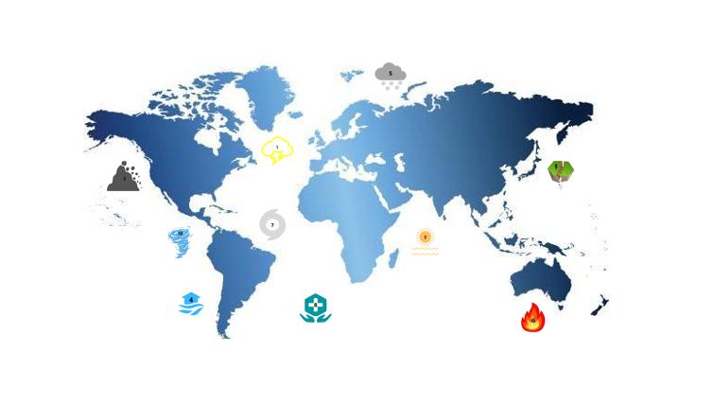

Once players enter the Disaster Challenge, a scenario will be presented in the form of a realistic situation, written bulletin, emergency warning, and/or news report.

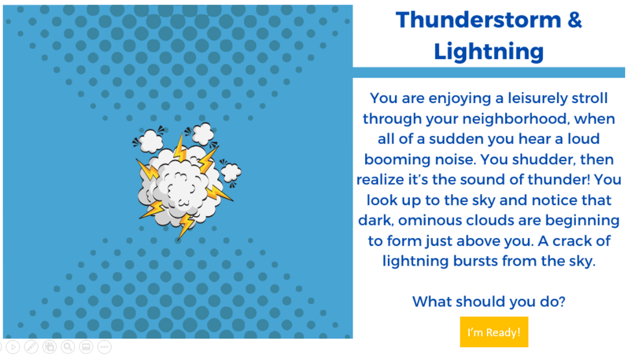

After reading or listening to the scenario, players will click “I’m Ready!” to be taken to a new screen that continues the scenario by starting a timer and giving players the option to choose one of three Disaster Packs to help them survive the disaster.

If players fail to choose a pack in the amount of time they are given, they will automatically be taken to a new screen that tells them they have run out of time and be prompted to return to the scenario, reread and/or re-listen to it, then try again.

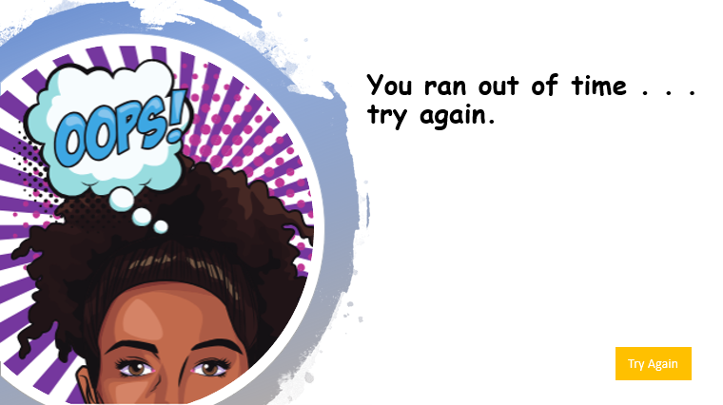

If players choose the correct Disaster Pack, they will be taken to a “Good!” screen and a brief explanation about why the pack they selected was the best choice to survive that particular disaster. They will also be awarded a Disaster Badge for the challenge.

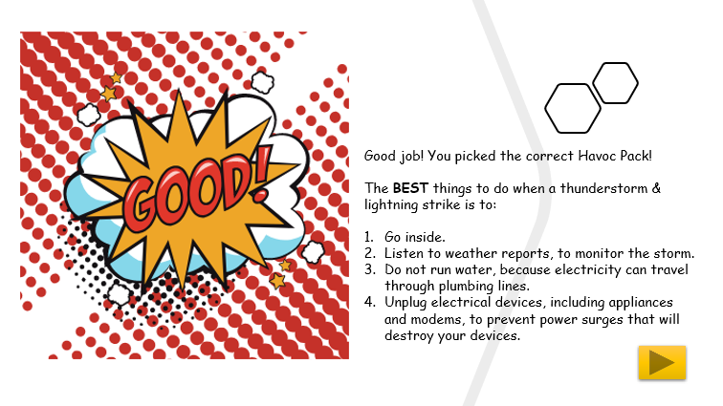

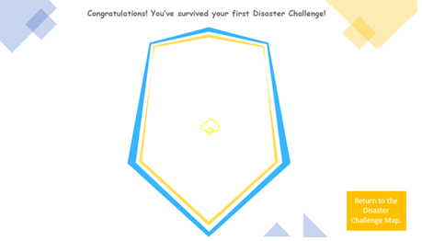

If players select incorrectly, they will be taken to an “Oh!” screen that explains why the pack was a bad choice/why the tools & resources, actions, and/or skills listed in the pack would not be helpful for surviving that particular disaster and prompted to try again.

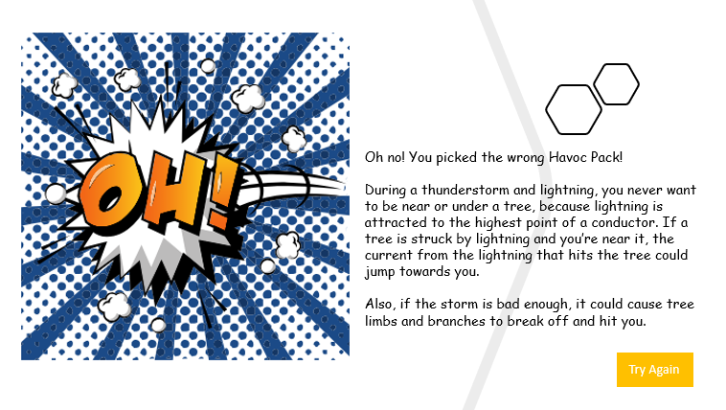

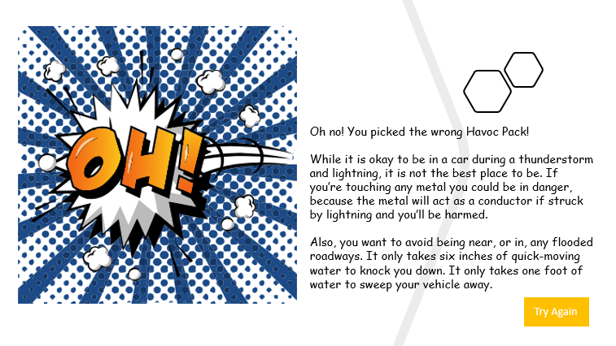

Play will continue with players returning to the world map screen and sequentially engaging in increasingly difficult Disaster Challenges, until they have earned all possible Disaster Badges. Once all badges have been earned, players will be awarded a complete Master of Havoc Badge.

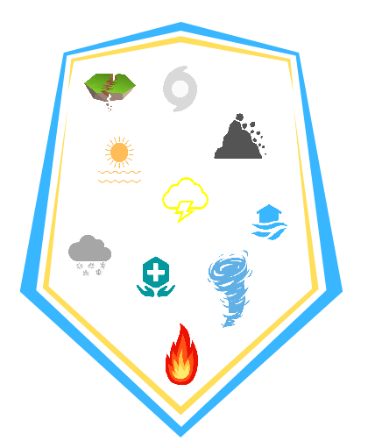

**Artificial Intelligence**

Players will use PowerPoint action buttons embedded in each screen to move through the game and select Disaster Packs (e.g., forward arrow button, numbered Disaster icons, I’m Ready! Disaster Packs, Try Again, Return to the Disaster Challenge Map). A timer will be used for each Disaster Challenge to force players to select a Disaster Pack within a certain amount of time, to simulate the idea that people have a limited amount of time to make decisions about how to survive a disaster.

**Game Elements**

A comic style/format will be used for visual appeal and cohesion throughout the game.

Players will start the game by clicking on the first Disaster Challenge icon on a map of the world.

The Disaster Challenge scenarios will be presented in second person “you,” so players can engage with the game as themselves.

Disaster Challenges/scenarios will be presented as realistic scenarios, bulletins, emergency warnings, and/or news reports/articles (e.g. a running bulletin at the bottom of a television screen, a cell phone emergency notification, news anchor and/or newspaper article). Sounds of the disasters/scenario presentations will be incorporated as appropriate/feasible (e.g., the sound of a thunderstorm, tornado, fire, earthquake, etc.)

The timer will be a countdown clock that shows players how much time they have to select the best Disaster Pack to survive the Disaster Challenge.

The Disaster Packs that players have to choose from will list different combinations of resources & tools, actions, and skills/traits to survive the Disaster Challenge (players will be prompted to choose the best pack when given three Disaster Pack options).

* *Tools & Resources* would include items such as a sturdy building, reliable information, bottled water, lighters, duct tape, batteries, flashlights, certain types of food, propane, etc.
* *Actions* would include specific actions one would need to take to survive/stay safe during a specific type of disaster. Actions would include doing things such as going inside, getting to higher/lower ground, moving to a doorway, taping windows, putting gas in a vehicle, purchasing ice, etc.
* *Skills/Traits* would include abilities such as quick thinking, strength, endurance, etc.

The Master of Havoc Badge will be built progressively, with an icon related to each Disaster Challenge added to the badge when a player successfully survives each disaster.

**Story Overview**

When disaster strikes, your ability to survive depends on the choices you make! Which tools & resources, actions, and skills do you need to survive a tornado? How about a wildfire? A hurricane? An earthquake? A pandemic? If your answer to these questions is “uhm, buy toilet paper and hand-sanitizer in bulk,” then sorry to say, you probably won’t make it. Learn what you’ll need to have and what you’ll need to do to survive virtually any disaster situation – make all the right choices and you’ll become a Master of Havoc!

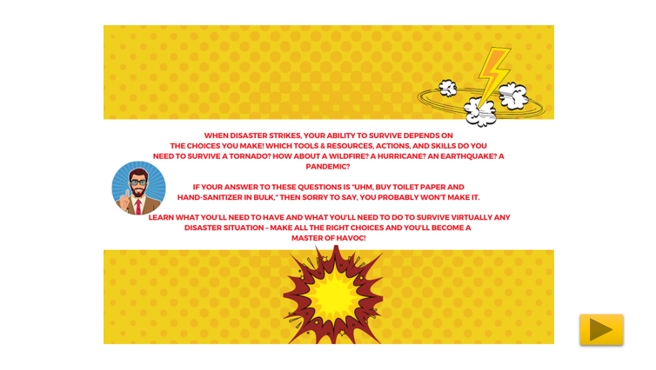

*Disaster Challenges*

1. Thunderstorm & Lightning
2. Heat Wave
3. Landslide
4. Flood
5. Blizzard
6. Wildfire
7. Hurricane
8. Pandemic
9. Earthquake
10. Tornado

**Game Progression**

The player board will be a map of the world with disaster icons placed in different countries/regions that represent either a manmade or natural disaster. Players will start by reading the game overview and general instructions about how to play the game. Then, players will be prompted to choose the first Disaster Challenge (e.g., thunderstorm & lightning) on the map to begin playing. Once a player clicks on the first Disaster Challenge, the disaster scenario will be presented, players will click “I’m Ready!” to begin, then a new screen will appear with a timer, and choose the best Disaster Pack (a list of tools & resources, actions, and skills/traits) to survive the disaster. If the player chooses the correct/best Disaster Pack, the player will be taken to a new screen with an explanation as to why that is the best Disaster Pack and will be awarded a Disaster Badge for the challenge. If they player chooses the wrong Disaster Pack, an explanation will be provided describing why certain components of the pack are not the ideal choice and will be given an opportunity to try again. Once the first badge is earned, the player will go back to the map and choose the next Disaster Challenge. Play will continue until all ten Disaster Badges are earned, and the player receives the complete Master of Havoc Badge.

**User Interface**

The game will be created using PowerPoint slides with action buttons/icons. Depending on the type of computer available, players may use a touchscreen or mouse to click the appropriate button and/or icon.

Because of the platform, players will need to download the game to their desktops, enable editing, and enable content. Then, they will need to play the slideshow from the beginning, and use the action buttons on each screen to move forward/engage with each disaster scenario.

**Implementation Artifacts and Guidelines**

*How to Play*

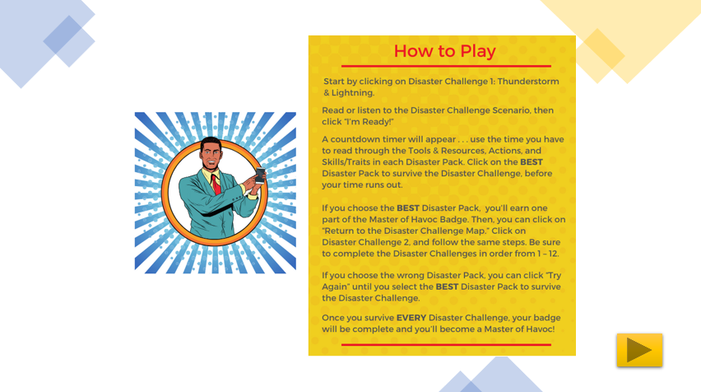

*Technical Requirements*

Players will need to have access to a computer and mouse/touch-screen, the ability to download the presentation from the internet, and PowerPoint.

While the game could likely be played on a tablet, the platform would not allow for play on a cell phone/through an app.

These requirements would make it possible for the majority of the target audience to access and play the game at home or in school.

*Guidelines for Educational Use*

Master of Havoc could be used as a tool to supplement/reinforce disaster and emergency preparedness curriculum that is already being implemented in schools across multiple cities and states (e.g., San Diego and Michigan). It could also be included as part of a larger classroom module on climate change and/or school safety/disaster preparedness, to help students and families better understand what they would need and what they would need to do to increase their chances of surviving a manmade or natural disaster. Additionally, it could be used to help teach “soft skills” such as critical thinking, problem-solving, and decision-making.

As a personal/self-education opportunity, the game could be made available on multiple, relevant national, state, and city government sites (e.g., HHS, Ready.gov, Denver.gov) to support citizens’ ability to prepare for and survive disaster situations that are common to their region (e.g., hurricanes, tornadoes, droughts) and the world at large (lightning & thunderstorms, pandemic).

**The Game Minute**

Once a player chooses a Disaster Challenge, the challenge will be presented in the form of a scenario (second-person). After reading and/or listening to the scenario, the player will click the “I’m Ready!” button and move to the Disaster Challenge screen. Once a player is on the Disaster Challenge screen, a timer will automatically begin a countdown to indicate the amount of time the player has to review then select the best of three Disaster Packs. If the player chooses (clicks on) the correct/best Disaster Pack, the player will be taken to a new screen with an explanation as to why that is the best Disaster Pack and will be awarded a Disaster Badge for the challenge. If the player chooses the wrong Disaster Pack, the player will be taken to a new screen with an explanation regarding why that pack was not the ideal choice and will be given an opportunity to try again.

REFERENCES:

Kalmpourtzis, G. (2019). Educational game design fundamentals: A journey to creating intrinsically motivating learning experiences. Boca Raton, FL: CRC Press.

Kickstarter.com “Disaster Games” search. Retrieved from <https://www.kickstarter.com/discover/advanced?ref=nav_search&term=disaster%20games>

Ready.gov (2020). Disasters and Emergencies (drop-down menu). Retrieved from <https://www.ready.gov/>

Ropeik, D. (2010). How risky is it really? Why our fears don’t always match the facts. McGraw Hill Education.

Images/Game Screenshots created by Shanti Flaherty using Canva.com